Project Design Phase-Il

Technology Stack (Architecture & Stack)

|  |  |  |
| --- | --- | --- |
| Date | 14 October 2022 |  |
| Team ID | PNT2022TMlD25031 |  |
| Pro•ect Name | Personal Ex ense Tracker A | lication |
| Maximum Marks | 4 Marks |  |

Technical Architecture:

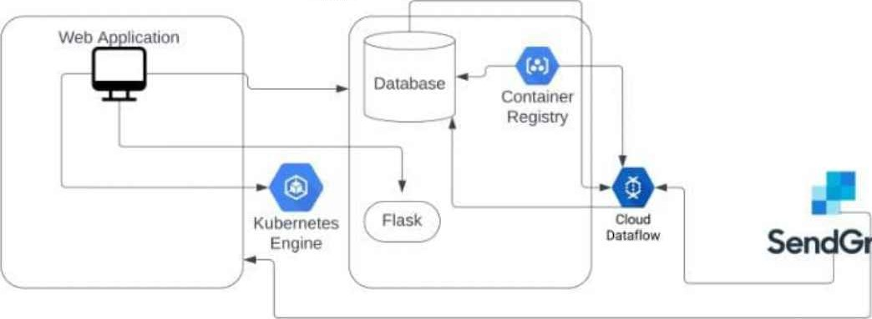

SendGrid

Node

Table-I : Components & Technologies:

|  |  |  |  |
| --- | --- | --- | --- |
| S.No | Component | Description | Technology |
|  | User Interface | How user interacts with application e.g. Web UI, Mobile , Chatbot etc. | HTML, CSS, JavaScript,Flask,Python. |
| 2. | Application Logic-Creating an account | Users using App;s UI can create an account | Python |
| 3. | Application Logic-Logging in | Users can log in with user name and password after creatin an account. | Flask App running using Kubernetes Cluster. |
| 4. | Application Logic-Creating An Ex ense | Users can add expenses in the portal using App's UI | Flask App running using Kubernetes Cluster. |
| 5. | Application Logic-Updating An Ex ense | Users can update the expenses. | Flask App running using Kubernetes Cluster. |
| 6. | Application Logic-Adding the bills | Users can add their bills using App's UI com onents. | Flask App running using Kubernetes Cluster. |
| 7. | Database | Data types will be user dependent as it is customisable,user can define it according to their use. | IBM DB2 |
| 8. | Cloud Database | Kubernetes Cluster services,Cloud's other services will be used. | IBM DB2 |
| 9. | File Storage | This requires hard disk of size 8GB RAM | HardDisk |
| 10. | External API-sendGrid | The app sendGrid will be used for giving alerts. | sendGrid services. |
| 11 . | Cloud | Application Deployment on Cloud  Cloud Server Confi uration : Virtual server for VPC | Local, Cloud Foundry, Kubernetes, etc. |
| 12. | Deployment | Application will be Deployment on Local System / Cloud  Local Server Configuration: The application will be running on the local server/client side to allow user to interact with Web UI components. | Cloud Foundry, Kubernetes,Cloud Registry. |

Table-2: Application Characteristics:

|  |  |  |  |
| --- | --- | --- | --- |
| S.No | Characteristics | Description | Technology |
| 1. | Open-Source Frameworks | Flask is a open source web framework, that is a Python module that lets you to develop web applications easily. It has a small and easy-to-extend core: it is a microframework that does not include an ORM OWect Relational Mana er or such features. | Flask services |
| 2. | Security Implementations | Access to the DB2 database system is managed by facilities that reside outside the DB2 database system (authentication). Kubernetes expects that all API communication in the cluster is encrypted by default with TLS, and the majority of installation methods will allow the necessary certificates to be created and distributed to the cluster com onents. | IAM Controls will be used for implementations. |
| 3. | Scalable Architecture | 3-tier architecture will be employed: Presentation tier — The UI is fixed for the application and thus scalability doesn't really apply to this tier.  Application tier — This tier comprises of the Python logic that will be used to provide the main functionali to thea lication | IBM DB2, IBM Cloud Object Storage, Kubernetes to run new container images |
| 4. | Availability | On a large scale, as majority of the application depends on the cloud, CDN's can be used and the storage can be distributed, i.e. data of the user would be stored in areas close to the user based on the availability of cloud servers which will enhance erformance. | IBM Cloud Object Storage, Kubernetes, Docker Images, IBM DB2, SendGrid |
| 5. | Performance | The performance of the application would currently be limited as the services employed belong to the trial version and would thus enable only a certain number of users etc, i.e., the performance of the application depends on the storage and compute sources available. | IBM Cloud Object Storage, Kubernetes, Docker Images, IBM DB2, SendGrid |